LAB 4
Part 1
FERMI-DIRAC DISTRIBUTION AND FERMI LEVEL

OBJECTIVE: to learn the concepts of
  - Fermi level, E_{F}, and the occupation probability of quantum states by an electron;
  - Temperature effect on electron distribution.
INTRODUCTION
From Schrödinger’s wave equation for a free electron confined to a three-dimensional infinite potential well (representing the crystal), the density of states per unit energy and per unit volume is given by
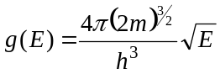 (1)
The density of allowed electronic energy states in the conduction band:
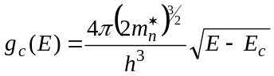 (2)
where equation (2) is valid for E ≥ Ec. As the energy of the electron in the conduction band decreases, the number of available quantum states also decreases.
The density of states function in the valence band is given by:
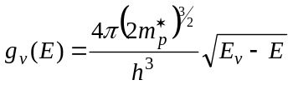 (3)
where equation (3) is valid for E ≤ Ev.
The Fermi-Dirac probability function is given by
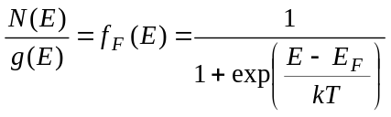 (4)
where N(E) is the number of particles per unit volume per unit energy and g(E) is the number of quantum states per unit volume per unit energy.
The Fermi-Dirac distribution gives the probability that an allowed quantum state at the energy E is occupied by an electron.
The parameter E_{F} is called the Fermi energy.
When E-E_{F} >> kT, so that the exponential term in the equation (4) is much greater than unity, the Fermi-Dirac distribution function becomes
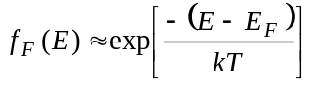 (5)
Equation (5) is known as the Maxwell-Boltzmann approximation to the Fermi-Dirac distribution function.
PROCEDURE
- Run the “Mathlab Animations” on your PC.
- Run “Section 1.5.2: Fermi-Dirac Distribution and Fermi Level”. Set the material energy gap, temperature and doping level to see the influence on carrier concentration. Comment on the changes in particles concentration, Fermi level and probability distribution with:
  - material energy gap change;
  - n-, p- type doping levels increase;
  - temperature change.
- Illustrate your answers with appropriate screenshots.

Part 2
CARRIER MOBILITY AND DIFFUSION. HAYNES-SHOCKLEY EXPERIMENT

OBJECTIVE: to learn the concepts of carrier drift and diffusion, experimental technique to determine mobility and diffusion coefficients for holes in a semiconductor.
INTRODUCTION
Drift and diffusion are two separate mechanisms. This can be demonstrated by the Haynes-Shockley experiment, illustrated in Figure 1. To monitor the process of drift and diffusion, a pulse of minority carriers is generated in a very narrow region of a semiconductor bar for a very short time interval. In the case shown in Fig.1 this is achieved by a flash of light that illuminates a narrow region at the end of an n-type silicon bar at time t = 0. The light generates both electrons and holes, however, the direction of the electric field applied is such that the electrons are quickly collected by the positive contact, while the holes have to travel through the silicon bar to be collected by the negatively biased contact. The drift velocity is v_{d} = µ_{p}E, and if the diffusion did not exist, a short current pulse would be detected by the ammeter as the holes are collected by the negative contact after the time interval equal to L/v_{d}. However, as the holes diffuse in either direction the hole distribution widens with time. As illustrated in the Fig. 1. The holes distribution can be expressed by the Gauss distribution:
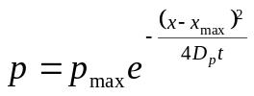 (6)
The position of the distribution peak (x = x_{max}) shifts as the holes drift along the electric field: x_{max} = v_{d}t.
Both the mobility and diffusion coefficient for the holes can be extracted from the measured time dependence of the current. Figure 1c illustrates that the maximum of the current coincides with the arrival of the peak of the holes distribution at the negative contact. The drift velocity can be calculated from the measured time between the current maximum and the flash of light as v_{d} = L/t_{max}. The mobility is then calculated as:
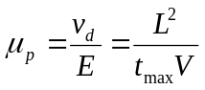 (7)
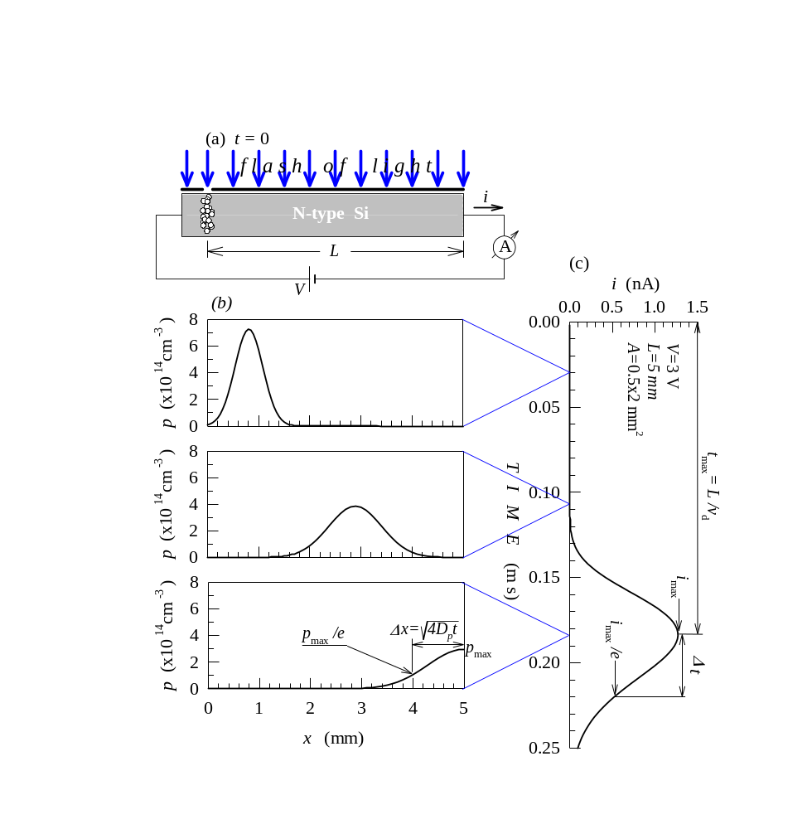
Figure 1. Haynes-Shockley experiment: (a) a flash of light is used to generate a narrow pulse of minority carriers (holes); (b) the motion of the hole peak illustrates the hole drift, while the widening of the hole distribution illustrates the hole diffusion, and (c) the measured current at the end of the semiconductor that can be used to calculate µ_{p} and D_{p.}

The diffusion coefficient can be determined from the width of the current pulse. Equation (6) shows that p = p_{max}/e for (x-x_{max})² = 4D_{p}t, that is Δx =x-x_{max} =√4D_{p}t
The current that corresponds to this distribution is i_{max}/e. As it takes time of Δt = Δx/v_{d} for the holes to travel the distance of Δx :
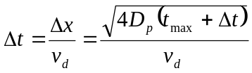 (8)
Using v_{d} = L/t_{max}, the diffusion coefficient can be expressed in terms of the measured values of t_{max} and Δt .
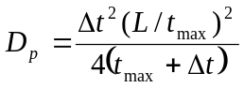 (9)
PROCEDURE
- Run the “Mathlab Animations” on your PC.
- Run “Section 1.4.4: Haynes-Shockley Experiment”.
- A first observe processes of drift and diffusion separately (using the “Drift” and “Diffusion” controls).
- Run Haynes-Shockley experiment clicking the “Both” control. Using a stopwatch measure the time from the beginning of the experiment (the moment you press “Both” control) to the end of the experiment (animation stops moving).
- Copy the resulting “Current vs. Time” graph in your report. Using the measurement of the total time, determine graphically t_{max} and Δt. For example, if the total measured time is 10 seconds, from the graph below t_{max}~5.5 sec and Δt~0.2 sec.
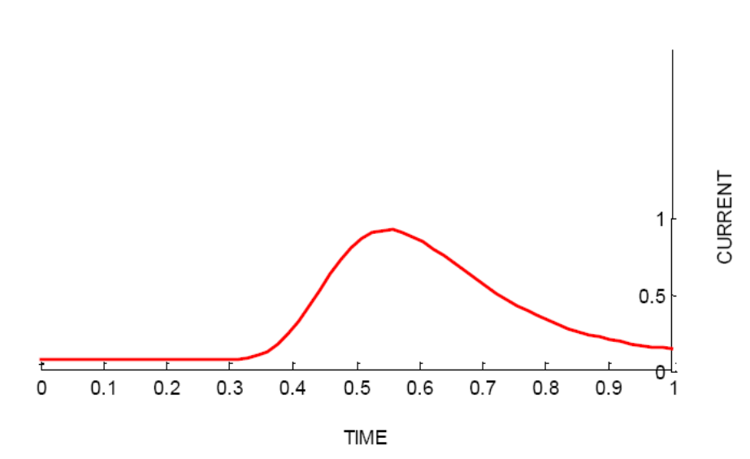
T_{total}= 10 sec
t_{max}~5.5 sec
Δt~0.2 sec
i_{max/}e

- Using the found values of t_{max} and Δt, calculate µ_{p} and D_{p} using equations (7) and (9). Assume L = 50 cm and V = 0.3 V.
- The diffusion coefficient D_{p} and mobility are not independent parameters, they are linked by the Einstein relation:
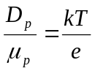
Diffusion coefficient should be approximately 40 times smaller in magnitude than the mobility at room temperature. Compare your results for D_{p} and µ_{p} . Does the Einstein relation hold for your data? Comment on the result.

